**Advanced Topics on Networks**

**Assignment 2**

**Q1: State the difference between the network and transport layers’ function.**

network layer: *logical communication* between hosts

transport layers: *logical communication* between processes

**Q2: State why TCP is reliable.**

* Congestion control
* Flow control
* Connection setup

**Q3: State why TCP socket uses 4-tuple and UDP uses 2-tuple.**

TCP: when sending data ,we need to establish the connection

UDP: when sending data ,not need to establish the connection

**Q4: State why UDP will be used for some application layer protocols.**

1-simple (no connection)

2- simple and fast

3-small header

4-no congestion control

**Q5: Using example to state why rdt3.0 limits use of physical resources.**

Ex:

1 Gbps link 15 ms prop .delay 8000bit packet:



U sender: utilization – fraction of time sender busy sending



1KB pkt every 30 msec -> 33kB/sec thruput over 1 Gbps link

network protocol limits use of physical resources

**Q6: State the main difference between Go-back-N and Selective repeat techniques.**

Go-back-N: cumulative ACK, retransmit all unacked packets

Selective Repeat: acks individual packets , retransmit only unack packet

**Q7: State and define the TCP header fields.**

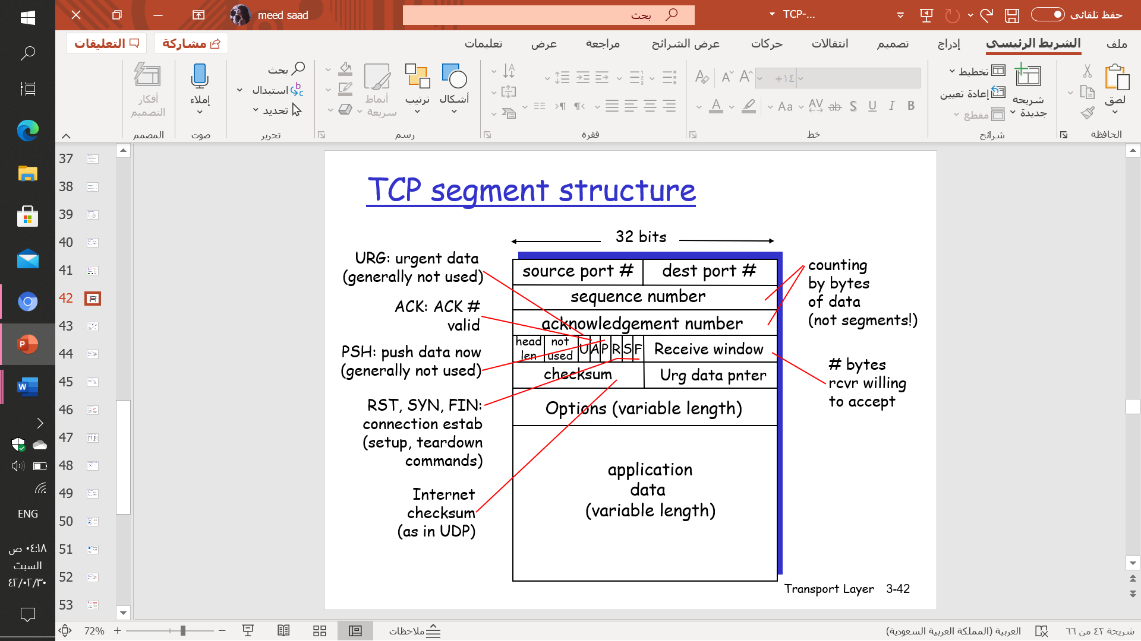

**Q8: State the three-way handshake process.**

Step 1: client host sends TCP SYN segment to server

* + specifies initial seq #
  + no data

Step 2: server host receives SYN, replies with SYNACK segment

* server allocates buffers
* specifies server initial seq. #

Step 3: client receives SYNACK, replies with ACK segment, which may contain data

**Q9: Using drawing to state the scenario1 and scenario 2 of congestion control.**

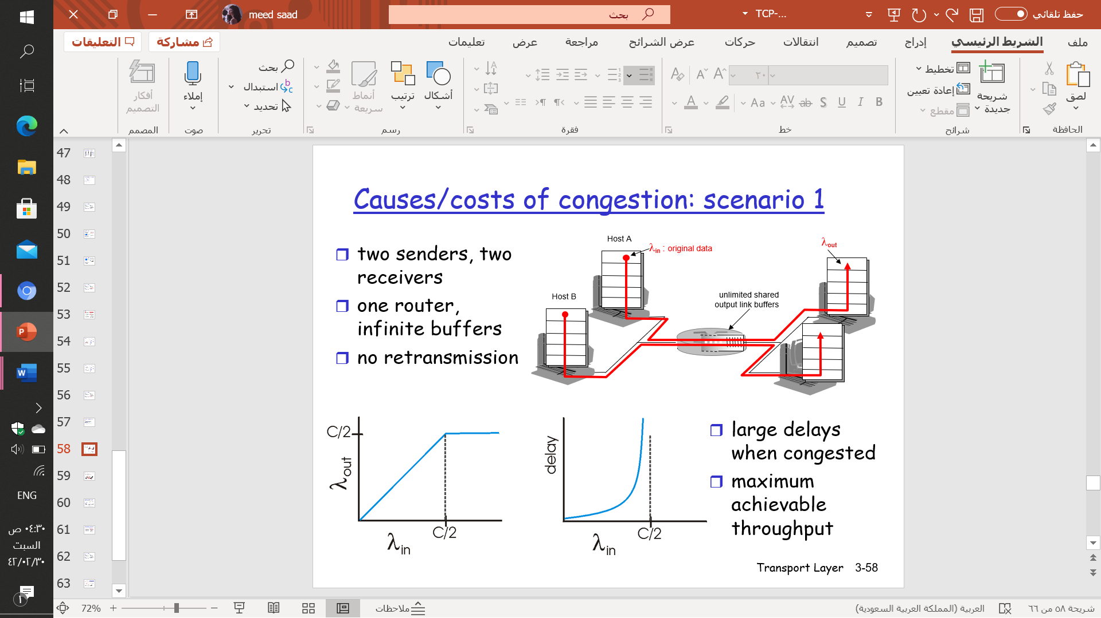 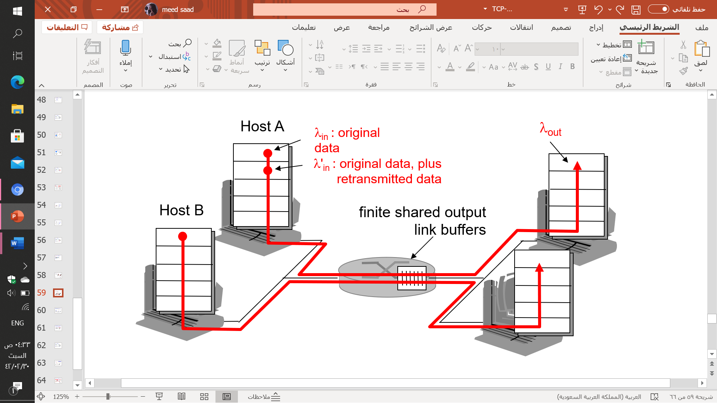

Two senders ,two revivers

One router ,infinite buffers

No retransmission

**Q10: Complete the following statements:**

1. Transport layer provide logical communication between application processes running on different hosts.
2. UDP is unreliable transport layer protocol.
3. TCP is reliable transport layer protocol.
4. Services, which are not available by TCP and UDP, are delay and bandwidth
5. Demultiplexing process is done at receiver host
6. Multiplexing process is done at sender host
7. UDP socket identified by two-tuple dest ip address and dest port number
8. TCP socket identified by 4-tuple, dest ip address, dest port number source ip address and source port number
9. UDP is connectionless transport layer protocol.
10. TCP is connection-oriented transport layer protocol.
11. SNMP and DNS are examples of application layer protocols that use UDP
12. Ckecksum technique is used for error detection.
13. Rdt 1.0 supposed that the underlying channel perfectly reliable.
14. In ACK, receiver explicitly tells sender that packet received OK
15. In NAK, receiver explicitly tells sender that packet had errors.
16. The new mechanisms in rdt2.0 are error detction and NAK and ACK
17. In rdt 2.2, duplicate ACK at sender results in same action as NAK: retransmit current packet.
18. Rdt 2.0 supposed that the underlying channel may flip bits in packet.
19. Rdt 3.0supposed that the underlying channel can also lose packets (data or ACKs).
20. In pipeline, sender allows multiple, “in-flight”, yet-to-be-acknowledged packets.
21. Go back N and selective repeat are considered as pipelining protocols.
22. In go back N, receivers only send cumulative ACKs.
23. In selective repeat, receivers only send ACKs for individual packets.
24. Fullduolex means bi-directional data flow in same connection.
25. Seq # is a byte stream “number” of first byte in segment’s data.
26. ACK # seq # of next byte expected from other side.
27. Flow control is defined as sender won’t overflow receiver’s buffer by transmitting too much, too fast.
28. Rcvwindow= RcvBuffer - [LastByteRcvd - LastByteRead].
29. In TCP flow control, sender limits unACKed data to rcvwindow
30. congestion is defined as too many sources sending too much data too fast for network to handle.
31. Manifestations of congestion occurrence are loss pkt and long delay
32. There are two broad approaches towards congestion control, end to end congestion and network-assisted congestion control
33. Increase CongWin by 1 MSS every RTT until loss detected is called addition increase
34. Cut CongWin in half after loss is called multiplicative decrease
35. Rate = congwin/ RTT.
36. In AIMD increase transmission rate (window size), probing for usable bandwidth, until loss occurs.